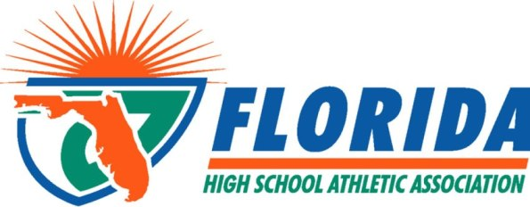
FHSAA OFFICIALS AWARD NOMINATION FORM
2017 ANNUAL STATE “ROOKIE OFFICIAL” OF THE YEAR

CRITERIA FOR THIS AWARD
For the first time, the FHSAA will be awarding One Top Rookie Official of the Year Award. Your nominees should be actively working contests, attending training sessions, received high evaluation marks from the association, and/or received accolades from schools in which they have worked contests. In general, they are a “Stand-Out Rookie Official.” In addition, this official must exemplify the highest standards of ethical conduct, moral character and carry the endorsement of their respective local association. Overall, they shall have made a recent significant contribution in their first year to high school officiating in your area.

INSTRUCTIONS
- Please choose one official to be nominated. One overall award will be presented.
- Information MUST be typed. List names below EXACTLY as the awards shall read if the individual were to win.
- Please include the following:
  - Number of contests worked by this official.
  - Number of training sessions attended by this official.
  - Evaluation ranking within your association.
  - Written accolades from schools about this official.
  - Any other information pertinent for this official to be considered.
- Send this completed form to Jeremy Hernandez via email: jhernandez@fhsaa.org no later than
May 5, 2017.
- Selections will be announced and awards will be presented at the 2017 FHSAA Officials Summer Conference.

NAME OF SPORT RECIPIENT’S NAME (as you want it to appear on award)

______________________ _____________________

OFFICIALS ASSOCIATION: SUBMISSION DATE:
OFFICIALS ASSOCIATION PRESIDENT (print):
This individual is a FHSAA local association member in good standing endorsed by our officials association for the State Rookie Official of the Year Award.
SIGNED:

