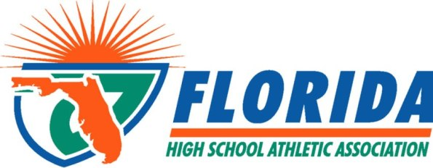

FHSAA
1801 NW 80th Blvd., Gainesville, FL. 32606
Phone: 352-372-9551 Fax: 352-244-0320 http://www.fhsaa.org

FHSAA OFFICIALS AWARD NOMINATION FORM
2017 STATE OFFICIAL OF THE YEAR

CRITERIA FOR THIS AWARD
FHSAA membership is mandatory for this active official award. Nominees should be actively working contests, attending training sessions, assigned to top playoff crews, been and received high evaluation marks from the association, and received accolades from schools in which they have worked contests. In addition, this official must exemplify the highest standards of ethical conduct, moral character and carry the endorsement of their respective local association. Overall, they shall have made a recent significant contribution to high school officiating in your area.

INSTRUCTIONS
- Determine the recipients of the “active official” awards within your Association. If your Association is only sanctioned for certain sports, you may only nominate officials for that sport(s). (i.e. Florida Professional Officials = Softball and Volleyball only)
- Information MUST be typed. List names below EXACTLY as the awards shall read if the individual were to win.
- Please include the following:
  - Number of contests worked by this official.
  - Number of training sessions attended by this official.
  - Evaluation ranking within your association (include all of your evaluated officials for comparision)
  - Playoff Crew ranking for this official
  - Written accolades from schools about this official
  - Any other information pertinent for this official to be considered
- Leave blank those spaces for which you may not award certificates.
- Send this completed form to Jeremy Hernandez via email: jhernandez@fhsaa.org no later than
May 5, 2017.
- Upon receipt, names will be entered into the FHSAA files.
- Selections will be announced and awards will be presented at the 2017 FHSAA Officials Summer Conference.

OFFICIALS ASSOCIATION: SUBMISSION DATE:
OFFICIALS ASSOCIATION PRESIDENT (print):
These individuals are FHSAA local association members in good standing endorsed by our officials association for the State Active Official of the Year Awards.
SIGNED:

SPORT RECIPIENT (name as you want it to appear on awards)

BASEBALL

GIRLS BASKETBALL

BOYS BASKETBALL

CROSS COUNTRY

FLAG FOOTBALL

FOOTBALL

GIRLS LACROSSE

BOYS LACROSSE

GIRLS SOCCER

BOYS SOCCER

SWIMMING
& DIVING

GIRLS TRACK & FIELD

BOYS TRACK & FIELD

SOFTBALL

GIRLS VOLLEYBALL

BOYS VOLLEYBALL

WATER POLO

WRESTLING

